A) Install GCC on your computer and verify the installation by running gcc --version in your terminal or command prompt.

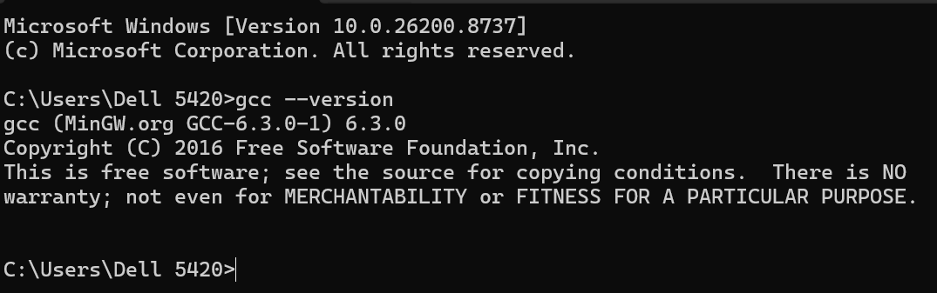
____________________________________________________________________________________________________________________________
B) Open VS Code or DevC++ and create a new file named hello.c. Write a C program that prints 'Hello, Instagram World!' to the console.

#include<stdio.h>
#include<conio.h>
void main()
{
printf("Hello, Instagram World");

getch();

}
_____________________________________________________________________________________________________________
C) Identify and label the header, main function, and return statement in your hello.c program using comments.

→ stdio and conio are header file.
→ main file is void main()
→ Return Statement is not present.

_____________________________________________________________________________________________________________
D) Compile your hello.c file using the GCC command line (gcc hello.c -o hello) and run the output file to display the message in your terminal.

